**1D**

f = input('Enter the signal: ');

n = size(f,2); % to take only column value i.e no of columns

k = zeros(n,n);

% DFT

for i = 1:n

for j = 1:n

if(i==1||j==1)

k(i,j) = 1; % alternative: k(1,:) = 1 and k(:,1) =1

else

arg = -2*pi*(i-1)*(j-1)/n;

k(i,j) = complex(cos(arg),sin(arg));

end

end

end

DFT = (k * transpose(f));

DFT

%IDFT

for i = 1:n

for j = 1:n

if(i==1||j==1)

k(i,j) = 1;

else

arg = 2*pi*(i-1)*(j-1)/n;

k(i,j) = complex(cos(arg),sin(arg));

end

end

end

IDFT = (k * DFT)/n;

IDFT

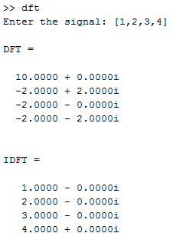

**2D**

f = imread('fish.png');

subplot(1,4,1);

imshow(f);

title('Original Image');

f = double(rgb2gray(f));

subplot(1,4,2);

imshow(f,[]);

title('Grayscale');

n = size(f,2);

k = zeros(n,n);

% DFT

for i = 1:n

for j = 1:n

if(i==1||j==1)

k(i,j) = 1;

else

arg = -2*pi*(i-1)*(j-1)/n;

k(i,j) = complex(cos(arg),sin(arg));

end

end

end

DFT = (k * f * k);

subplot(1,4,3);

imshow(DFT);

title('DFT');

%IDFT

for i = 1:n

for j = 1:n

if(i==1||j==1)

k(i,j) = 1;

else

arg = 2*pi*(i-1)*(j-1)/n;

k(i,j) = complex(cos(arg),sin(arg));

end

end

end

IDFT = (k * DFT * k)/n;

subplot(1,4,4);

imshow(IDFT,[]);

title('IDFT');

